**TECHNICAL REPORT**

**Introduction**

This report presents a comprehensive analysis of sales patterns, Revenue generated, and customer demographics for Subway performance analysis by examining historical sales data. The goal is to uncover essential performance indicators, explore seasonal fluctuations, and offer strategic recommendations to enhance revenue generation and streamline operational efficiency. The dataset used for this project is a sales dataset.

**Story of data**

This data was collected from surveys.

Source: From a senior data analyst (Sales dataset).

Contents: Customer performance, Regional sales, shipping details, Sales person performance, Product performance analysis, and amount of each transactions.

**Data Structure**

**The data is organized in rows and columns with customers being in column** including revenue, region, salespersons, and product categories are included in the dataset, which consists of sales transactions.

Key Highlights and Their Importance: The story emphasizes the critical contributions of key figures, especially Nancy Freehafer, who was recognized as the top sales performer. Additionally, Company D distinguished itself as the leading partner in terms of performance. The data also shows a notable geographical focus on New York, which emerged as the top shipping destination, while Beverages led as the most successful product category**.**

**Data Splitting and Preprocessing**

Project split into dependent and independent variables.

**Independent Variables:**

Order date

customer name

city

country

sales person

region

ship city

payment type

product name

category

D**ependent Variables**:

Unit price

Quantity

Revenue

Shipping fee

**Data Cleaning**

Eliminated duplicate entries and rectified discrepancies in data values.

Unified product categories and standardized pricing information.

Converted date formats to ensure accurate time-series analysis.

Addressed missing data points for improved consistency.

**Industry**: Retail & E-commerce

**Stakeholders**: The CEO

what value means to this industry is revenue creation.

**Pre analysis**

**Sales Trends**

Month with the highest sales was December, and Febuary was the lowest.

Northern region generated the highest revenue, while the West was the least.

Beverages is the highest-grossing category, and Dried nuts and fruits.

**Regional Performance**

Northern region has revenue of $141660.34 with a good performance

the lowest was the western region with the revenue of $91251.98 they need targeted marketing.

**Correlations**

Higher sales is to revenue correlation

There is a positive correlation between faster shipping and higher order values.

**Product category** Beverages had the highest revenue and dried fruits and nuts with the lowest

Customer ranking Company D has the highest revenue

**Shipping City Analysis**

New york being the best ship city and Milwaukee the lowest ship city.

**Sales person analysis** The top sales person is Nancy Freehafer

Pre-Analysis

Before diving into the detailed analysis, several preliminary observations set the stage for understanding Subway performance analysis 2016.

Initial Observations

- Annual Revenue: $435,036.16

- Top Regional Contribution: Northern Region

- Product Category: Beverages $110,927.11

- Top Salesperson Revenue: Nancy Freehafer $192,545.24

- Top Customer : Company D $97,946.55

- Best Month: December $82,642.78

**In-Analysis**

**Regional analysis**

The best region is the northern region with the revenue of 141660.34. and the region with the lowest was the western region with the revenue of 91251.98

**City analysis**

New York City

finding out the sales persons recident in the northern region, inquire measures they implemented and convey to the persons in the north.

**Transaction analysis**

The goods sold at 0-1000 were the highest sold goods with the count of 218 times, so goods sold from 0-1000 were mainly bought by most people. I recommend that prices of goods within this range should be offered more frequently or make goods within that price range be more available. Customers who spend more could be identified. they can be grouped as premium customers.

**Shipping city analysis**

New york being the best ship and Milwaukee the lowest ship city.

Setting up HQ at the new york to ensure more customers get interested in lower shipping fee encouraging more unacquired customers.

**Product category**

The best performing product for the year is beverages with the revenue of 110577.11.I recommend that stakeholders informs all inventory staffs to always stock up the beverages the coming year such that it does not finish up.

**Sales person performance**

Nancy performed best for the year 2014 by generating revenue of 104242.34.

Jan performed least for the year and i recommed to stakeholders therefore should be sent for training on cusatomer retention.

Nancy performed the best and i recommend that she can be put in regions with low revenue in order to implement measures in the north for these regions.

**Customer performance analysis**

Company D performed best for the year by revenue of 67180.5.

I recommend that he should be given discount for the products he buys next year and they can also be given free gifts.

Analytical tool used:

Pivot Tables serves as the key tool in this analysis, it is used to find the correlation between independent value and dependent value.

**Post-Analysis and Insights**

Highest ranked month being December contributed significantly to annual revenue.

Beverages contributed the highest to the revenue.

Nancy contributed mostly to company revenue, and company D had significant contributions.

Comparison with Initial Expectations

Sales were expected to be evenly distributed, but findings indicate strong seasonality.

Business Growth:

Boost marketing initiatives during December periods to capitalize on peak periods.

Drive sales growth in underperforming regions, particularly the South, through targeted, localized promotions.

Profitability Enhancement:

Promote the use of premium shipping by offering faster delivery options bundled with high-value purchases.

Customer Retention:

Launch loyalty programs to reward repeat customers.

Provide personalized promotions for corporate clients to maximize high-value transactions.

**Data visualization and charts**

**Bar chart: Top city by revenue**

New York's having the highest sales.

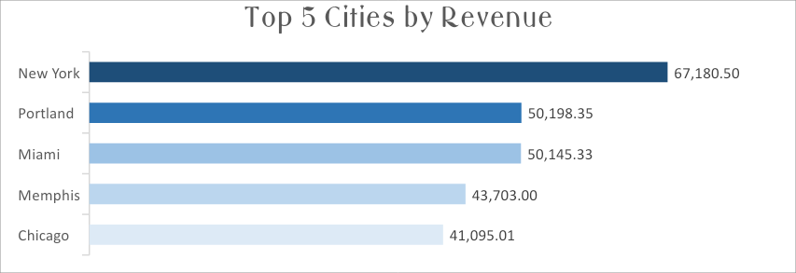

**Line chart: Sales trend**

Analysing trends of the market by The month we had the highest sale was December with a grossing revenue of 66642.78 and the lowest sale was on Febuary with 19955.5.

**Column chart: Transactions by amount**

The goods sold at 0-1000 were the highest sold goods with the count of 218 times, so goods sold from 0-1000 were mainly bought by most people.

**Pie chart: Sales by ship city**

New york being the best ship and Milwaukee the lowest ship city.

**Column chart: Product category**

The best performing product for the year is beverages with the revenue of

110577.11

**Bar chart: Sales person performance**

Nancy performed best for the year 2014 by generating revenue of 104242.34.

**Bar chart: Customer performance analysis**

Company D performed best for the year by revenue of 67180.5

**Don't chart: Regional analysis**

The best region is the northern region with the revenue of 141660.34. and the region with the lowest was the western region with the revenue of 91251.98

**Conclusion**

This analysis offers strategic insights to optimize pricing strategies, enhance customer retention, and expand regional market presence. By leveraging these recommendations, Subway performance can foster sustainable growth and improve profitability.